REGISTRATION FORM

REGISTERING IN: Pre-K (K4) Kindergarten Grade 1 Grade 2 Grade 3

School Year: ________ Is your child registered in Cree-Ative Wonders daycare? Yes No

DEMOGRAPHICS:
Legal Last Name: _____________________________
Legal First Name: _____________________________
Legal Middle Name: ___________________ Home Street Address ______________________
Mailing Address: _______________________________________________________________
Date of Birth: _____________________________
Proof of age: Please provide copy of birth certificate.
Care Card Number: _____________________ Is your child immunized? Yes No
Band Name: _____________________________ Status Number:_________________________

PARENT/GUARDIAN INFORMATION:
Name: ___________________________________ Contact can pick up: Yes
Relationship to child: __________________ Contact lives with student? Yes
Address (if different from the student): ________________________________________
Cell #: _____________________________ Work #: _____________________________
Email: ________________________________________

Name: ___________________________________ Contact can pick up: Yes
Relationship to child: __________________ Contact lives with student? Yes
Address (if different from the student): ________________________________________
Cell #: _____________________________ Work #: _____________________________
Email: ________________________________________

ALTERNATE CONTACTS: (Other than Parents/Guardians)
The following persons are authorized to pick up my child in case of an emergency.
Contact 1 ___________________ Cell #: ________ Work #: ________ Relationship _________
Contact 2 ___________________ Cell #: ________ Work #: ________ Relationship _________

STUDENT LEGAL ALERTS - Court Order on File?
Description ____________________________________________________________________
STUDENT MEDICAL ALERTS – Life Threatening?
Description ____________________________________________________________________
OTHER STUDENT ALERTS - Health, Family, or Other Information
Description ____________________________________________________________________

PERMISSIONS: By my initial and signature, I consent to the following.
PHOTOGRAPHS AND VIDEOS: I give permission for photographs and videos of my child to be used in any publicity in which the Saulteau first Nations (SFN)/ Muskoti Elementary School (MES) participates (e.g. newsletter, SFN and MES Facebook pages). INITIAL __________
Signature of Parent/Guardian: _____________________________________________________
CULTURAL EDUCATION: I give permission for my child to participate in the Muskoti Elementary School’s cultural programming. This programming includes local traditional language and practices such as smudging. INITIAL _________
FIELDTRIPS AND EXCURSIONS: I give permission for my child to go on excursions with the Saulteau First Nations – Muskoti Elementary School to places of interest that are no more than thirty minutes driving distance from the school. I understand that on planned trips to Chetwynd and the surrounding area, my student will be bused to and from these places. INITIAL _________
PARENTAL WAIVER FORM: I confirm I am let parent/legal guardian of the child named on this registration form. I do herby give my consent to their participation in the activities of the Muskoti Elementary School. I waive and release all claims for damages, injuries, or losses including loss of personal property against the school. INITIAL _________

Signed: _____________________ Print Name: ___________________ Date:_________

School Bus Transportation Liability Waiver

As a parent/guardian of the student(s) named below, I hereby release the Saulteau First Nations, the Muskoti Elementary School, and the Muskoti Learning Centre, its representatives, and employees from all liability arising out of their transportation on the school bus.

The Saulteau First Nations, through its Department of Education, provides free school bus transportation. The utilization of this service shall in no way obligate the Saulteau First Nation, the Muskoti Elementary School, or the Muskoti Learning Centre for any reason.

I understand that it is my full responsibility as a parent/guardian to:
- Call the School at (250) 788-3955 by 12:00 pm if transportation plans change due to an emergency.
- Use one pick-up and drop-off point listed on this form.
- Adhere to a regular schedule. No daily changes: there is a set routine for busing.
- Place my student on the bus in the morning and meet my student at the bus stop at the end of the day.
- Instruct my student regarding their pickup and drop-off points.
- Review the School Bus Rules with my student as set forth in the School Policy.
- Make other transportation arrangements when there is no school bus
transportation on days that schools are closed or when the weather does not permit busing services, but the Muskoti Elementary School is in session.
- Provide emergency contacts. These individuals will be contacted if no one is present to meet the student at the scheduled time and location, and the student will be left in their care.

Emergency Contact: _____________________________________________________
(Name) (Numbers)
Emergency Contact: _____________________________________________________
(Name) (Numbers)
Child’s Name: ______________________ | Child’s Name: ______________________
Child’s Name: ______________________ | Child’s Name: ______________________

Pickup/Drop off location: __________________________________________________

Parent/Guardian Signature: ________________________ Date: _____________

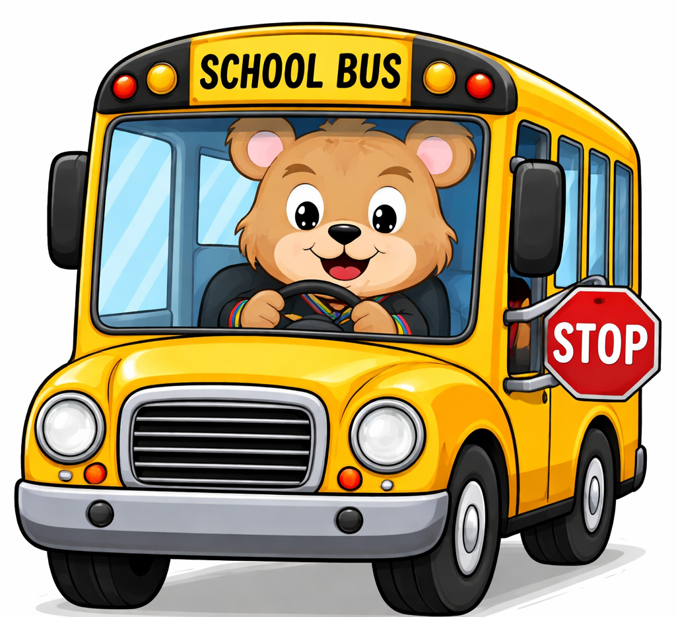
Please indicate if your student will be a regular bus student or only ride the bus for fieldtrips.
Daily Busing: Fieldtrips only:

